**CHAPTER 4: SIMULATIONS AND RESULTS**

**4.1. DELAY DEPENDENT STABILITY:**

Computation of stability delay margin:

The objective is to compute the maximum value of the delay ($τ^{*}$) within which the closed loop system remains asymptotically stable. In this problem, all the load frequency control system parameters are known and The PI controller parameters $K_{p}$ and $K_{I }$ are assumed to be known.

**Simulink Model of Single Area LFC control system with EV aggregator:**

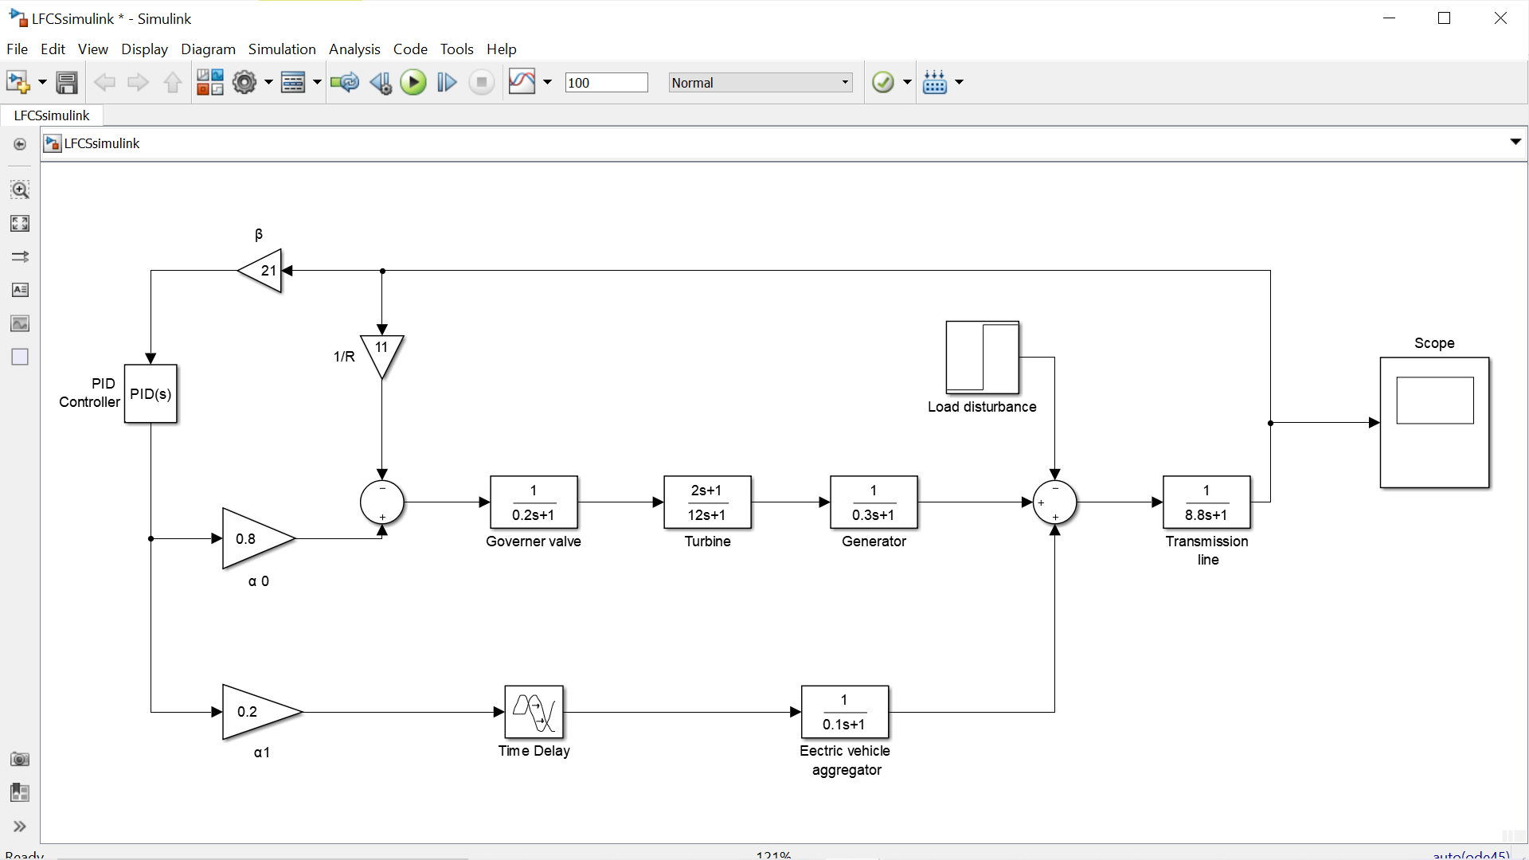

Fig 4.1 Simulink Model of Single Area LFC control system with EV aggregator.

**4.1.1 BENCHMARK SYSTEM PARAMETERS:**

|  |  |  |  |
| --- | --- | --- | --- |
| **SL.NO** | **PARAMETERS** | **DESCRIPTION** | **VALUE** |
| 1. | **M** | Generator inertia constant | **8.8** |
| 2. | **D** | Damping Coefficient | **1** |
| 3. | $$T_{g}$$ | Governor Time Constant | **0.2** |
| 4. | $$T_{C}$$ | Generator Time Constant | **0.3** |
| 5. | $$T_{r}$$ | Reheat and Turbine Time Constant | **12** |
| 6. | $$F_{P}$$ | Fraction of total turbine power | **1/6** |
| 7. | **R** | Speed drop | **1/11** |
| 8. | $$β$$ | Frequency bias factor | **21** |
| 9. | $$K_{EV}$$ | Gain of EV aggregator | **1** |
| 10. | $$T_{EV}$$ | Time Constant of EV aggregator | **0.1** |

Table 4.1 Parameters of LFC system.

These are the benchmark parameters used to compute the maximum value of the delay ($τ^{*}$) within which the closed loop system remains asymptotically stable.

The MATLAB program to compute the stability delay margin is given below,

**4.1.2 MATLAB code for computation of stability delay margin**:

clear ALL

M= 8.8;

D= 1;

Tg= 0.2;

Tc= 0.3;

Tr= 12;

Fp= 1/6;

R= 1/11;

Beta= 21;

Kev= 1;

Tev= 0.1;

alpha0= 0.8;

alpha1= 0.2;

Ki = 0.6;

Kp = 0.2;

p6= (M*R*Tg*Tr*Tc*Tev);

p5= (D*R*Tg*Tr*Tc*Tev) + (M*R) *(Tg*Tr*Tc + Tr*Tc*Tev + Tg*Tc*Tev + Tg*Tr*Tev);

p4= (D*R) *(Tg*Tr*Tc + Tr*Tc*Tev + Tg*Tc*Tev + Tg*Tr*Tev) + (M*R) *(Tr*Tc + Tg*Tc + Tg*Tr + Tc*Tev + Tg*Tev+ Tr*Tev);

p3= (D*R) *(Tc*Tr+ Tg*Tc + Tg*Tc + Tg*Tr + Tc*Tev + Tr*Tev + Tg*Tev) + (M*R) *(Tc+Tr+Tg+Tev) +(Fp*Tr*Tev) + (alpha0*Beta*R*Kp*Fp*Tr*Tev);

p2= (D*R) *(Tc+Tr+Tg+Tev) +(M*R) +(Fp*Tr) +Tev+(alpha0*Beta*R) *(Kp*Tev + Kp*Fp*Tr + Ki*Fp*Tr*Tev);

p1= (D*R) + 1 + (alpha0*Beta*R) *(Kp+ Ki*Tev + Ki*Fp*Tr);

p0= (alpha0*Beta*R*Ki);

q4= (alpha1*Beta*R*Kev*Kp*Tg*Tr*Tc);

q3= (alpha1*Beta*R*Kev) *(Kp*Tr*Tc + Kp*Tg*Tc + Kp*Tg*Tr + Ki*Tg*Tc*Tr);

q2= (alpha1*Beta*R*Kev) *(Kp*Tc + Kp*Tr + Kp*Tg + Ki*Tr*Tc + Ki*Tg*Tc +Ki*Tg*Tr);

q1= (alpha1*Beta*R*Kev) *(Kp + Ki*Tc + Ki*Tr + Ki*Tg);

q0= alpha1*Beta*R*Kev*Ki;

t12= p6^2;

t10= p5^2 - 2*p6*p4;

t8 = p4^2 + 2*p6*p2 - 2*p5*p3 - q4^2;

t6 = p3^2 - 2*p6*p0 - 2*p4*p2 + 2*p5*p1 + 2*q4*q2 - q3^2;

t4 = p2^2 + 2*p4*p0 - 2*p3*p1 - 2*q4*q0 + 2*q3*q1 - q2^2;

t2 = p1^2 - 2*p2*p0 + 2*q2*q0 - q1^2;

t0 = p0^2 - q0^2;

k=1;

r = roots ([t12 t10 t8 t6 t4 t2 t0]);

for i=1: size(r,1)

an(i)=angle(r(i)) *(180/pi);

if (an(i)==0)

w1(k)=r(i);

k=k+1;

end

end

m = 0;

for n = 1: size(w1,2)

wa (: n) = sqrt (w1(: n));

wc = wa (: n);

derWc = 6*t12*wc^10 + 5*t10*wc^8 + 4*t8*wc^6 + 3*t6*wc^4 + 2*t4*wc^2 + t2;

RT = sign(derWc);

if(RT==1)

m = m+1;

P = p6*(j*wc) ^6 + p5*(j*wc) ^5 + p4*(j*wc) ^4 + p3*(j*wc) ^3 + p2*(j*wc) ^2 + p1*(j*wc) ^1 + p0;

Q = q4*(j*wc) ^4 + q3*(j*wc) ^3 + q2*(j*wc) ^2 + q1*(j*wc) ^1 + q0;

SIN = imag(P/Q);

COS = real(-P/Q);

theta = atan(SIN/COS);

if COS<0

tau1(:m) = ((theta+pi)/wc);

else

tau1(:m) = (theta/wc);

end

RT;

wc;

tau1;

else

RT;

wc;

end

end

Kp

Ki

format long g

tau = min(tau1)

format

**The result of the above-mentioned MATLAB code is:**

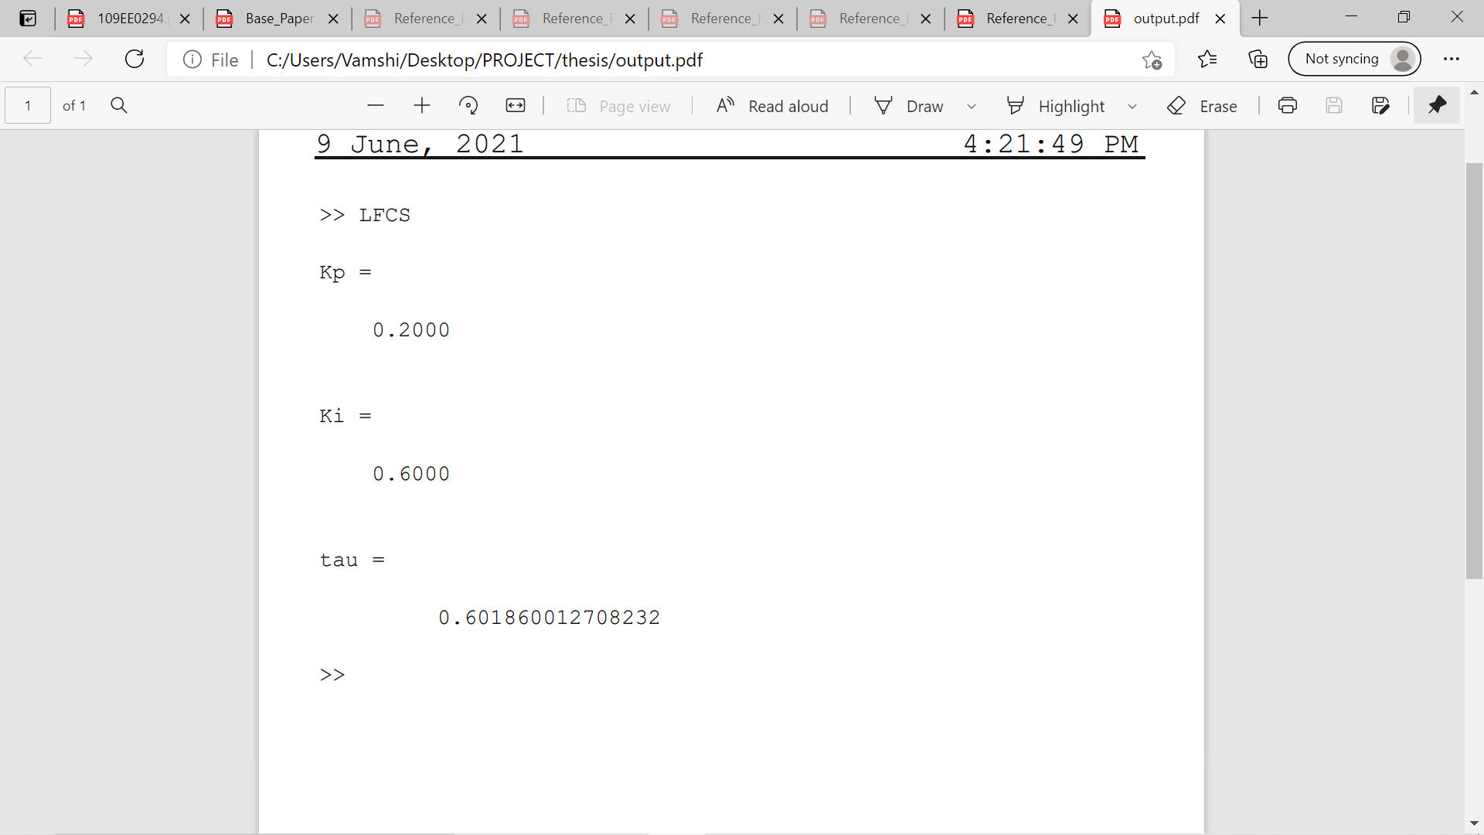

**4.1.3 MATLAB output for different $K_{p}$ and $K_{I}$ values:**

$τ^{*}$**-**  STABILITY DELAY MARGIN (s)

|  |  |  |  |  |  |
| --- | --- | --- | --- | --- | --- |
| **Kp** | **KI=0.2** | **KI=0.4** | **KI=0.6** | **KI=0.8** | **KI=1.0** |
| **0** | 1.7866 | 0.4231 | 0.0859 | -0.0615 | -0.1417 |
| **0.1** | 2.7421 | 0.8271 | 0.3496 | 0.1340 | 0.0134 |
| **0.2** | 3.5861 | 1.2002 | **0.6018** | 0.3242 | 0.1656 |
| **0.3** | 4.2522 | 1.5214 | 0.8327 | 0.5034 | 0.3115 |
| **0.4** | 4.6970 | 1.7773 | 1.0346 | 0.6669 | 0.4477 |
| **0.5** | 4.8537 | 1.9635 | 1.2023 | 0.8108 | 0.5717 |
| **0.6** | 4.6817 | 2.0829 | 1.3339 | 0.9327 | 0.6812 |
| **0.7** | 4.3135 | 2.1433 | 1.4300 | 1.0317 | 0.7751 |
| **0.8** | 3.9050 | 2.1545 | 1.4932 | 1.1080 | 0.8527 |
| **0.9** | 3.5197 | 2.1273 | 1.5275 | 1.1628 | 0.9142 |
| **1.0** | 3.1740 | 2.0715 | 1.5372 | 1.1982 | 0.9606 |

Table 4.2 stability delay margin for various $K_{p}$ and $K_{I}$ values.

**4.1.4 SIMULATION RESULTS:**

Stability analysis for various communication delays. This simulation results shows the impact of communication delay in the load frequency control system integrated with electric vehicle aggregator.

1. **For $K_{p}$ =0.2, $K_{I}$ =0.6 and Communication Delay, τ*= 0.6018 sec  
     
   Marginal stable response**:

In this, the frequency response exhibits sustained oscillations which indicate the marginal stability of LFC-EV system.

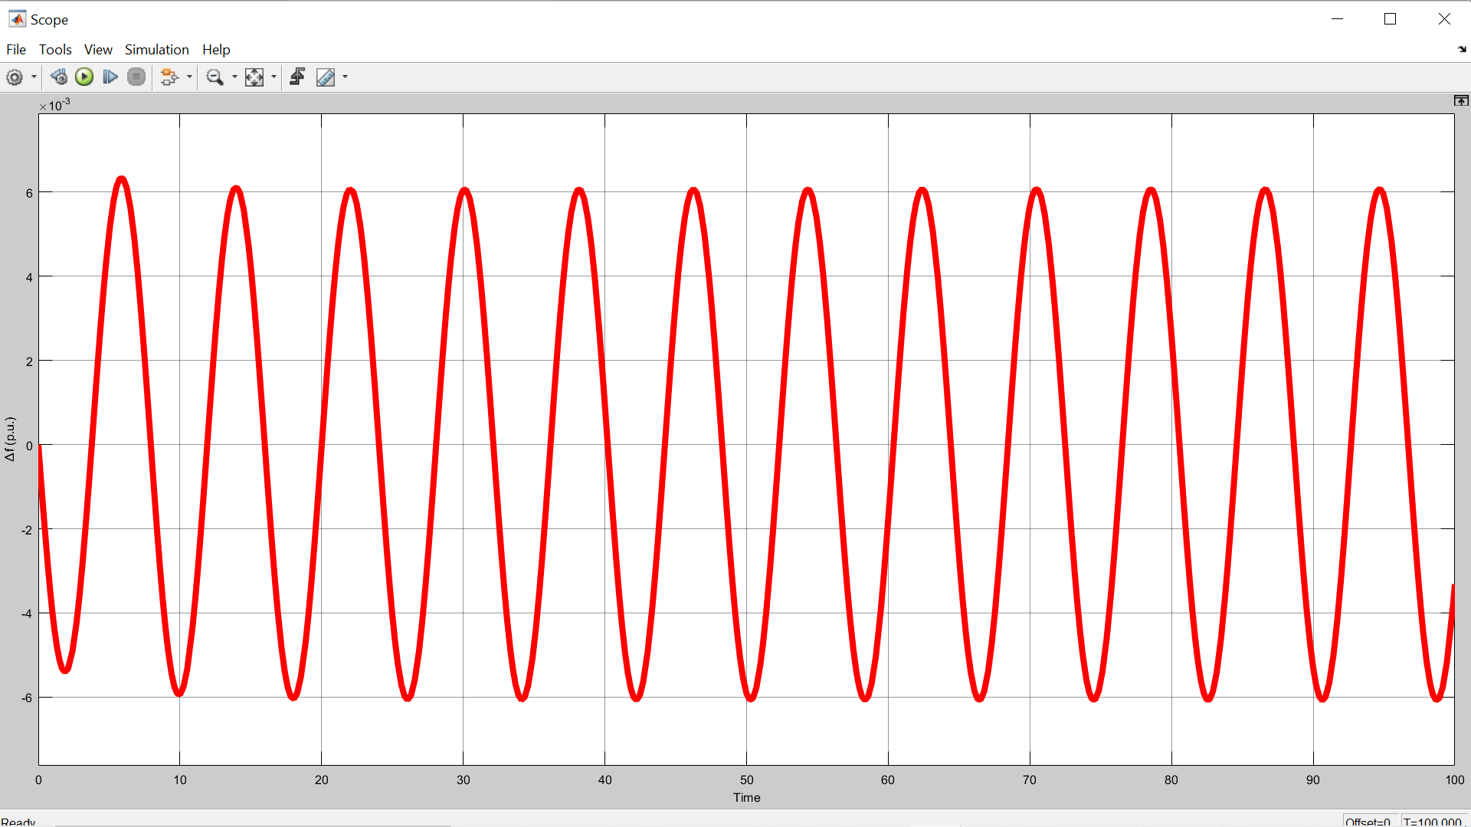

Fig 4.1 the plot of incremental frequency vs time for τ*= 0.6018 sec

1. **For $K_{p}$ =0.2, $K_{I}$ =0.6 and Communication Delay,** **τ*= 0.5751 sec  
   Stable response:**

In this, the frequency response exhibits decaying oscillations which indicate the stability of LFC-EV system.

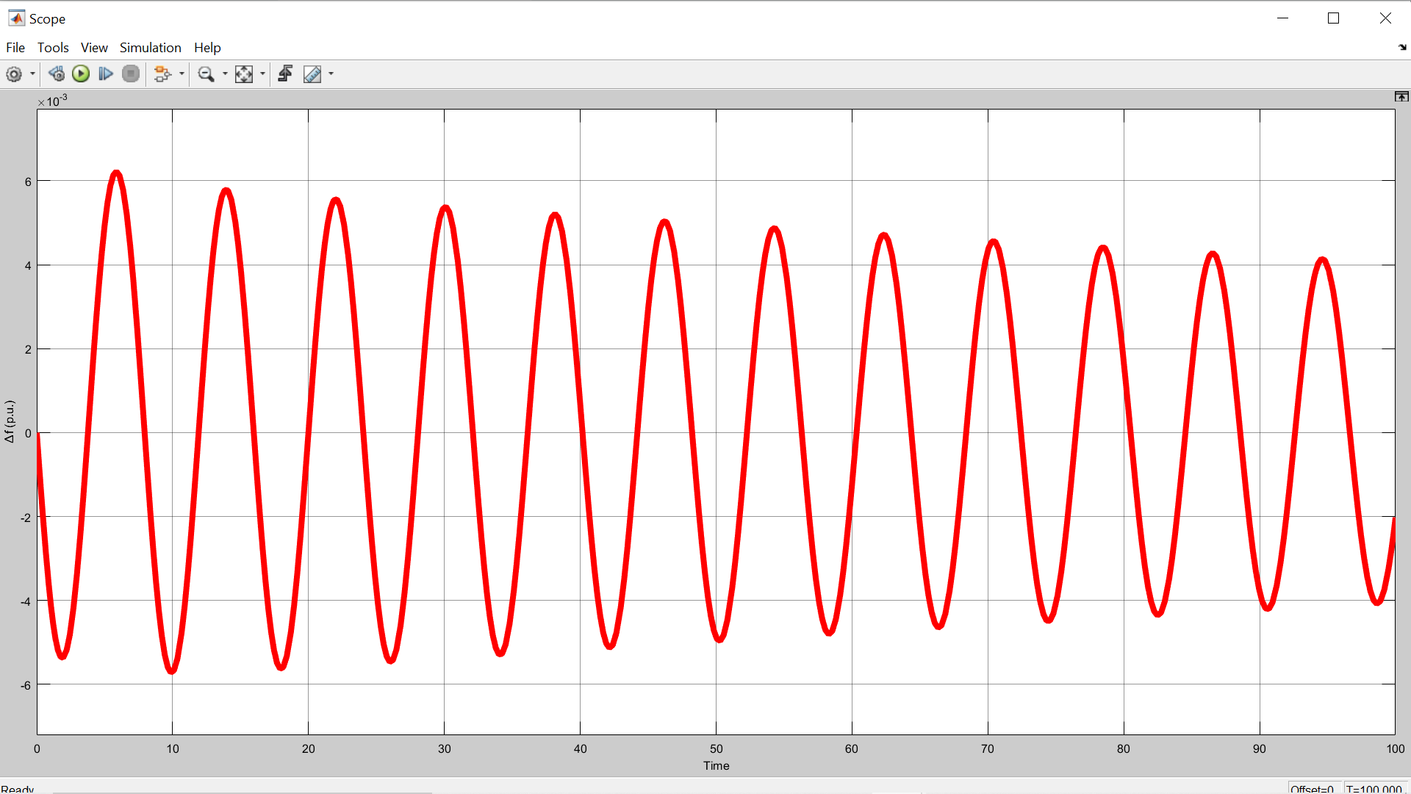

Fig 4.2 the plot of incremental frequency vs time for τ*= 0.5751 sec

**3. For $K_{p}$ =0.2, $K_{I}$ =0.6 and Communication Delay,** **τ*= 0.6252 sec**

**Unstable response:**

In this, the frequency response exhibits growing oscillations which indicate the instability of LFC-EV system.

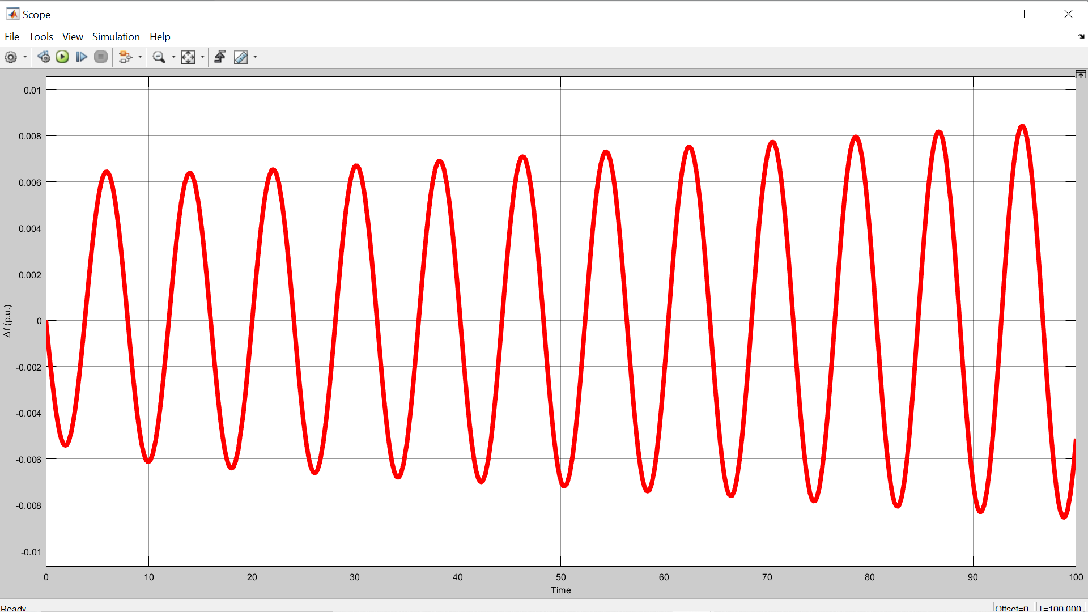

Fig 4.3 the plot of incremental frequency vs time for τ*= 0.6252 sec

**4.2 COMPUTATION OF STABILITY DELAY MARGINS:**

The objective is to compute a feasible origin in PI controller parametric space. In this problem, all the LFC system parameters except controller parameters are known. The time-delay in the communication network is assumed to be known.

The MATLAB program to compute the stability delay regions is given below,

**4.2.1 MATLAB CODE FOR COMPUTATION OF STABILITY REGIONS:**

Clear all

M=8.8;

D=1;

Tg=0.2;

Tc=0.3;

Tr=12;

Fp=1/6;

R=1/11;

beta=21;

Kev=1;

Tev=0.1;

alpha1=0.1;

alpha0=0.9;

Q4=Kp*[alpha1*beta*R*Kev*Tg*Tr*Tc];

Q3= Kp*[alpha1*beta*R*Kev*[Tr*Tc+Tg*Tc+Tg*Tr]];

Qq3=Ki*[alpha1*beta*R*Kev*Tg*Tr*Tc];

Q2=Kp*[alpha1*beta*R*Kev*[Tc+Tr+Tg]];

Qq2=Ki*[alpha1*beta*R*Kev*[Tr*Tc+Tc*Tg*Tc+Tg*Tr];

Qq0=Ki*[alpha1*beta*R*Kev*Ki];

Q1=Kp*[alpha1*beta*R*Kev];

Qq1=Ki*[alpha1*beta*R*Kev*[Tc+Tr+Tg]];

p6=M*R*Tg*Tr*Tc*Tev;

p5=D*R*Tg*Tc*Tr*Tev+M*R*[Tg*Tr*Tc+Tr*Tc*Tev+Tg*Tc*Tev+Tg*Tr*Tev];

p4=D*R*[Tr*Tg*Tc+Tr*Tc*Tev+Tg*Tc*Tev+Tg*Tr*Tev]+M*R*[Tr*Tc+Tg*Tc+Tg*Tr+Tc*Tev+Tr*Tev+Tg*Tev];

p3=D*R*[Tr*Tc+Tg*Tc+Tg*Tr+Tc*Tev+Tr*Tev+Tg*Tev]+M*R*[Tc+Tr+Tg+Tev]+Fp*Tr*Tev;

P3=Kp*[alpha0*beta*R*Fp*Tr*Tev];

p2=D*R*[Tc+Tr+Tg+Tev]+M*R+Fp*Tr+Tev;

P2=Ki*[alpha0*beta*R*[Tev+Fp*Tr]];

Pp2=Ki*[alpha0*beta*R*Fp*Tr*Tev];

p1=D*R+1;

P1=Kp*[alpha0*beta*R+1];

Pp1=Ki*[alpha0*beta*R*[Tev+Fp*Tr]];

Pp0=Ki*[alpha0*beta*R];

t = 0.5;

wc = 0:0.01:3.91;

for i=1:size(wc,2)

A1(:,i) = -P2*wc^2+Q4*wc^2*cos(wc*t)-Q2*wc^2*cos(wc*t)-Q3*wc^3*sin(wc*t)+Q1*wc*sin(wc*t);

B1(:,i) = -Pp2*wc^2+Pp0-Qq2*wc^2*cos(wc*t)+Qq0*cos(wc*t)-Qq3*wc^3*sin(wc*t)+Qq1*wc*sin(wc*t);

A2(:,i) = -P3*wc^3+P1*wc-Q3*wc^3*cos(wc*t)+Q4*wc^4*sin(wc*t)+Q2*wc^2*sin(wc*t);

B2(:,i) = Pp1*wc-Qq3*wc^3*cos(wc*t)+Qq1*wc*cos(wc*t)+Qq2*wc^2*sin(wc*t)-Qq0*sin(wc*t);

C1(:,i) = -p6*wc^6+p4*wc^4-p2*wc^2;

C2(:,i) = p5*wc^5-p3*wc^3+p1*wc;

Kp(:,i) = (B1(:,i)*C2(:,i)-B2(:,i)*C1(:,i))/(A1(:,i)*B2(:,i)-A2(:,i)*B1(:,i));

Ki(:,i) = (A2(:,i)*C1(:,i)-A1(:,i)*C2(:,i))/(A1(:,i)*B2(:,i)-A2(:,i)*B1(:,i));

end

end

plot(Kp,Ki)

hold on

x = 0;

y = -0.03:0.0001:0.059;

plot(y,x,'k')

grid

axis([-0.04 0.07 -0.02 0.12])

xlabel ('Proportional Controller Gain K_{P}')

ylabel ('Integral Controller Gain K_{I}')

title ('Stability Region for \tau=0.5')

**The result of the above-mentioned MATLAB code is:**

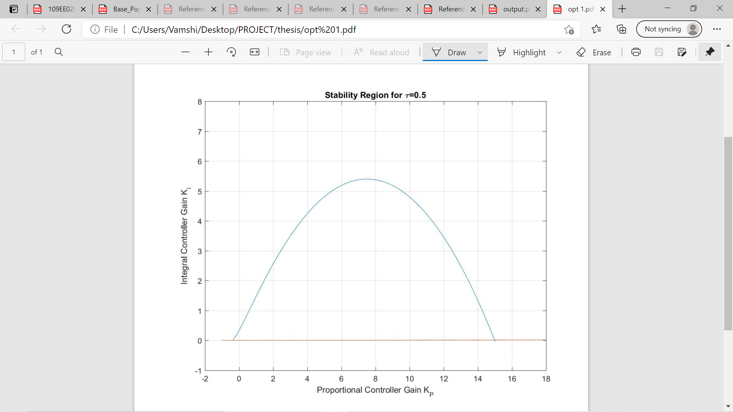

**4.2.2 STABILITY REGION CURVE FOR TIME DELAY=0.5s FOR VARIOUS PARTICIPATION FACTORS:**

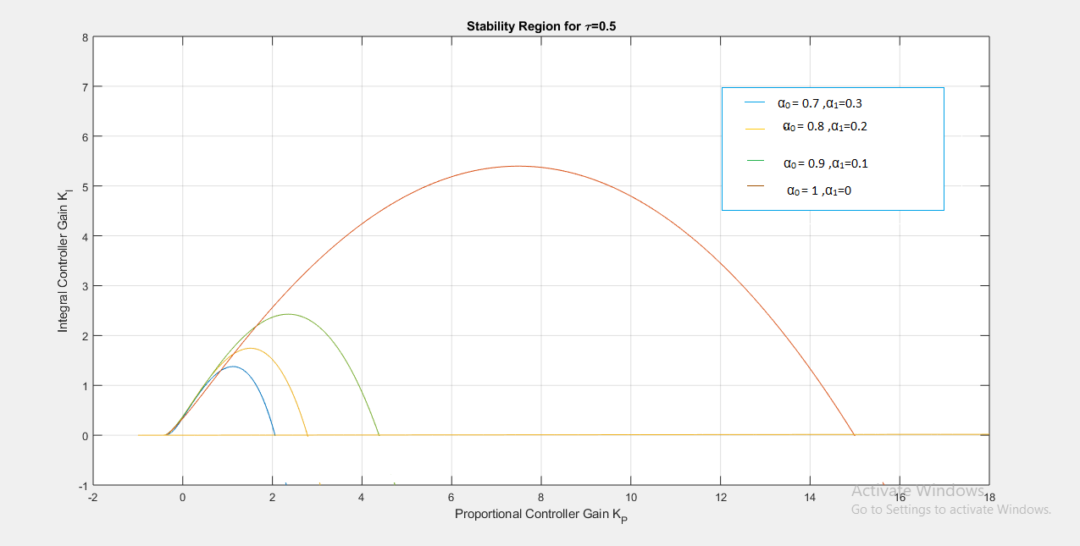

Fig 4.4 The plot of integral controller gain KI vs proportional controller gain Kp.

1. **For system to be stable:**  The values of Kp and KI should lie within the curve boundary for that participation factors.

Example: For α1=0.3 and α0=0.7 the values are Kp =1 and KI =0.5.

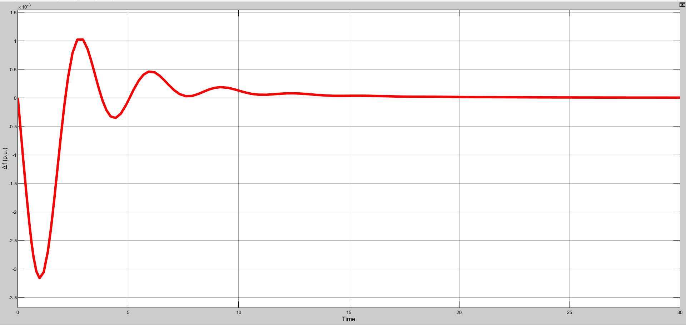

Fig 4.5 The plot of incremental frequency vs time for Kp =1 and KI =0.5.

1. **For system to be unstable:**  The values of Kp and KI should lie anywhere out of curve boundary for that particular participation factors.

Example: For α1=0.3 and α0=0.7, the values are Kp =3 and KI =2.

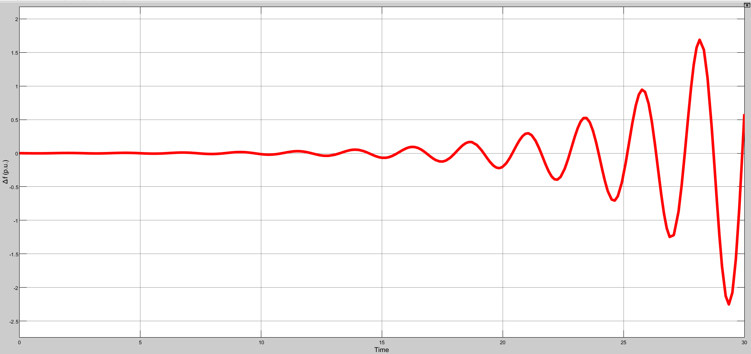

Fig 4.6 The plot of incremental frequency vs time for Kp =3 and KI =2.

1. **For system to be marginally stable:** The values of Kp and KI should lie on or near to the curve boundary for that particular participation factors.

Example: For α1=0.3 and α0=0.7, the values are Kp =1.8 and KI =1.4.

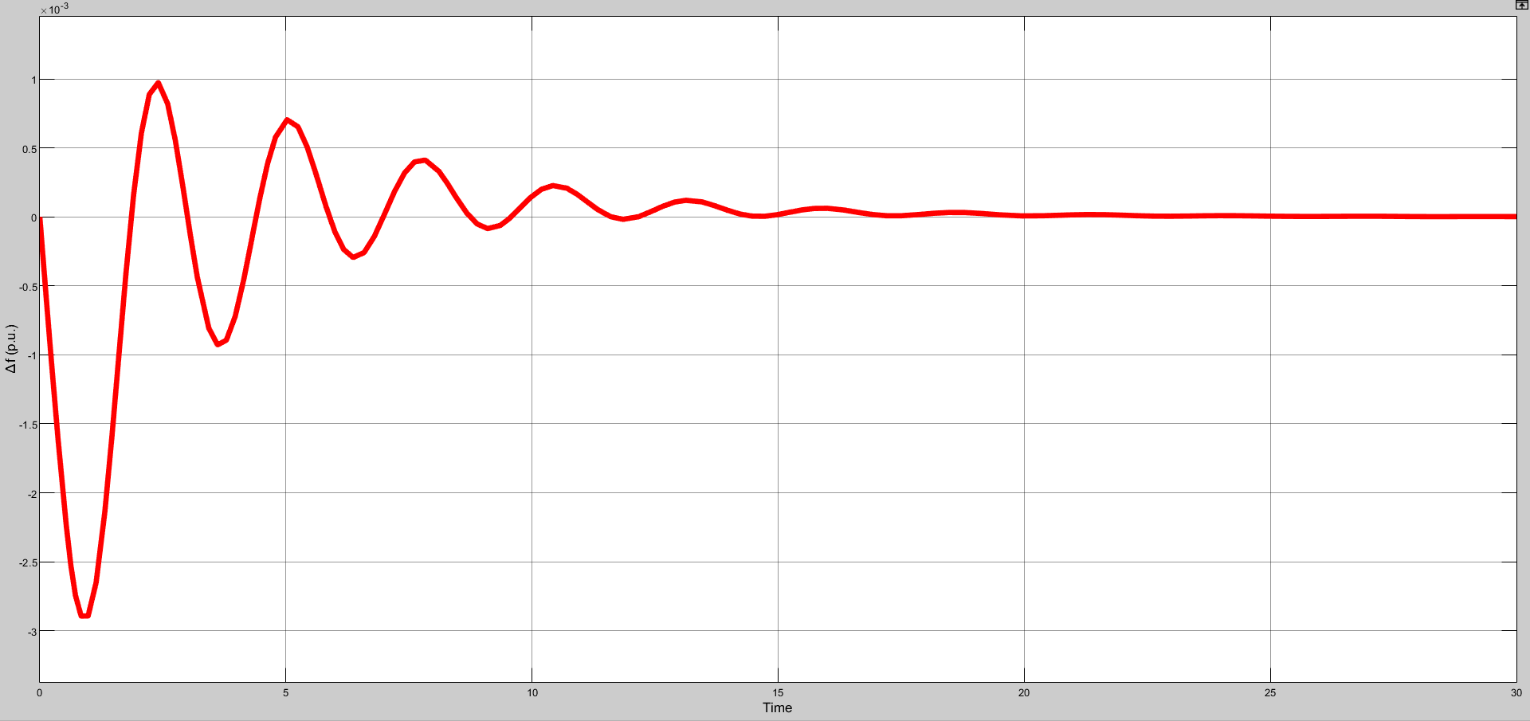

Fig 4.7 The plot of incremental frequency vs time for Kp =1.8 and KI =1.4.

**4.3 CONCLUSION:**

Stability delay margins are computed for a wide range of PI controller gains. The stability delay margins are shown in Table 4.1 for EV participation factor of $α_{1}$ = 0.2. The results in Table 4.1 indicate that for a fixed value of $K_{P}$, the stability delay margin decreases when $K_{I}$ is increased, which infers a less stable system. The stability delay margin increases with $K_{P}$ for nearly all values of $K_{I}$. The theoretical delay margins are verified using time domain simulations. The frequency response exhibits sustained oscillations which indicate the marginal stability of LFC-EV system. If the time delay exceeds the stability delay margin, the system will become unstable due to the growing oscillations in the frequency response.

The stability region in the ( $K_{P},K_{I}$)-plane is obtained for without EV aggregator and with three different EV aggregator participation factors $α_{1}$ = 0.1, 0.2 and 0.3, whereas the time delay is fixed at τ = 0.5 s. These participation factors imply that 10%, 20% and 30% of therequired control efforts are provided by the EV aggregator with a time delay of τ = 0.5 s. Figure 4.4 compares the corresponding stability regions. Note that the largest region is observed when EV participation is not considered ( $α_{1}$ = 0). More importantly, the size of stability regions decreases as the EV participation factor increases, whereas the shape of the regions is unchanged. Figure 4.4 clearly illustrates that the stability regions get smaller as the contribution of EV aggregator to the frequency regulation increases due to the presence of communication time delay. the accuracy of stability boundary locus is validated by the time-domain simulations. It can be seen that the LFC-EV system is marginally stable due to undamped frequency response because of a complex conjugate root pair located on the jω-axis for the selected gains. This implies that the LFC-EV system will be asymptotically stable with decaying oscillation in the frequency response for any PI controller gains inside the region. The LFC-EV system will become unstable with growing oscillations in frequency for any controller gains outside the region.